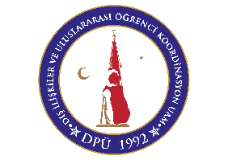
KUTAHYA DUMLUPINAR UNIVERSITY
International Relations Office
Request for extension of ERASMUS+ study abroad period
Student’s Personal Data
Name, surname:
E-mail:
Receiving Institution:
Original length of stay (from...to...):
Extension (from...to...):
I apply for the above stated extension of my study abroad period.
Place, Date:
Student’s Signature
Approval of the Receiving Institution:
Name and function of signatory: Signature:
Place, Date Stamp:

Approval of the Sending Institution (DPÜ Departmental ERASMUS+ coordinator):
Name: Signature:
Place, Date: Stamp:

Procedure:
1. The student fills in the form, signs and obtains the signature of the responsible person at the host institution,
2. The application has to be sent to the student’s departmental coordinator at the Kütahya Dumlupınar University,
3. The departmental coordinator of the Kütahya Dumlupınar University approves the application and sends the form to the student.
4. The student sends the form to outgoing.students@dpu.edu.tr

