ERASMUS+ ÖĞRENCİ HAREKETLİLİKLERİ BİLGİLENDİRME TOPLANTISI – MEMNUNİYET ANKETİ

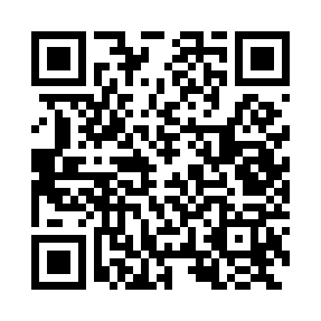
Link: https://forms.gle/KLNyMnxCSwFfKXFp8

